PROGRAM
import cv2

img = cv2.imread("scaling_image.png")

if img is None:
print("Image not found! Check the image name.")
else:
rotated = cv2.rotate(img, cv2.ROTATE_90_CLOCKWISE)

cv2.imshow("Original Image", img)
cv2.imshow("Rotated Image - 90 Degrees Clockwise", rotated)

cv2.imwrite("rotated_image.png", rotated)

cv2.waitKey(0)
cv2.destroyAllWindows()

print("Rotated image saved successfully!")

OUTPUT
The original image and the image rotated by 90 degrees clockwise are displayed. The rotated image is saved as rotated_image.png.

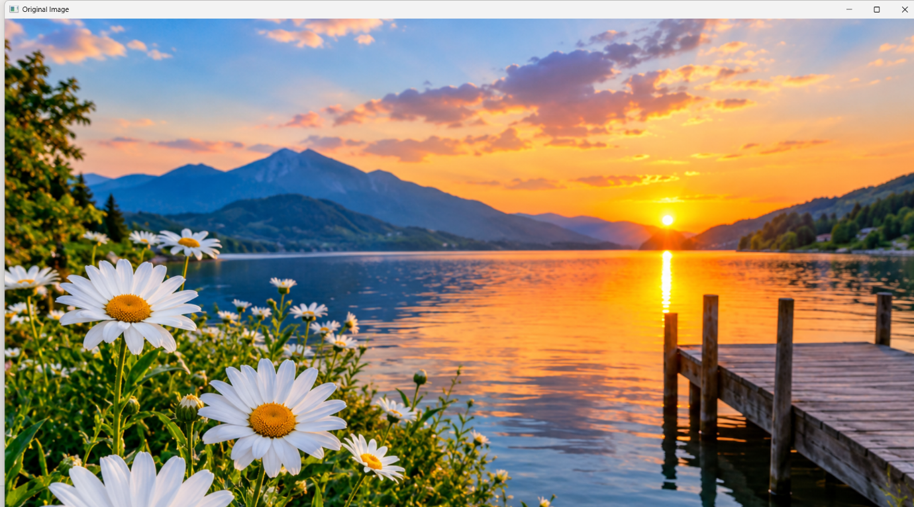

RESULT
Thus, the image was successfully rotated by 90 degrees clockwise using Python and OpenCV.

